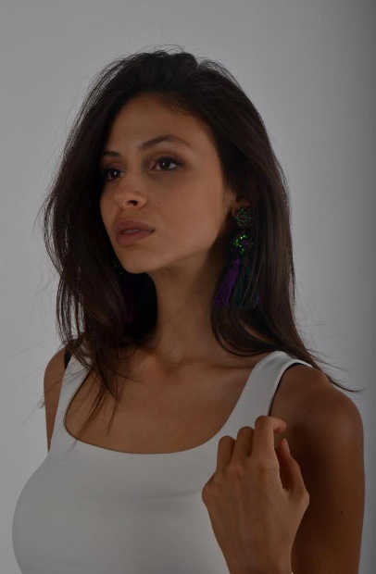

Tamara Radovanovic
actress

- rep: Candida di Bonaventura
Fox and Gould Produzioni
Roma,Italy
- phone: +381631898670
- mail: tamara259.radovanovic@gmail.com

Born and raised in Belgrade,Serbia,where she later finished primary and high school. She started learning piano as a five year old which later inspired her to start an acting school called 'Dadov' when she was seven. She finished music school piano and singing and won many republic and international music competitions . In primary school she attended many plays in Belgrade theatre. She was in model agency called 'Crystal' for a long time and done few music videos there. She did a master class in theatre 'Madlenianum',then later she became a part of the ansamble . Started faculty of drama and film arts in Belgrade in 2015. Sings in a band called 'Trojka'. From her work experience she highlights work with Emir Kusturica in Autumn festival on Mecavnik,commercial for swiss company,music video for famous band Lexington,tv show 'Ubice mog oca' and 'Prva Tarifa' and a movie called 'Patuljci sa naslovnih strana'
Work experience:

2014 - Autor and presenter of news on faculty
2016 - Role of Nadezda fon Mek in play 'Quad fatum'
2016- Role in a student movie called 'ESC'
2016 - Role of Angela in play 'Underfloor'
2017 - Presenter for TV Hram
2017 - Music video for Lexington band
2017 - Role in 'Cinderella' play for kids
2017 – Commercial for Singidunum university
2017- music video for band ‘Maraqja’ for MTV
2017- Role in tv show 'Ubice mog oca 2'
2017- Role in tv show 'Prva Tarifa' for Prva TV
2017-Role of sister Jovic in movie 'Patuljci sa naslovnih strana'
2017-Role in tv show 'Sifra despot'
2017- role in Madlenianum play called 'SENKA',directed by Ivana Vujic
2018-role in play 'Prisutnost' in Madlenianum
2018- role in tv show 'ER'
2018-role in tv show 'Ordination'

Education:

2004-2010 Music school 'Vatroslav Lisinski'-piano
2011-2015 15th Belgrade High School
2013-2015 Music school 'Davorin Jenko'-singing
2015- Faculty of drama and film arts

Skills:

- 2007.-Part of dance studio Beo Dance
- 2015.-Modeling school 'Crystal'
- 2011.-PR and actress for cultural organisation called 'Kulturni element'
- 2011.-journalist course
- 2016.-singer in band 'Trojka' in Belgrade,Montenegro,Skopje and other
- Opera masterclass in 'Madlenianum'
- Piano player
- DJ-ing

My IMDb page

