Ada Dumitru

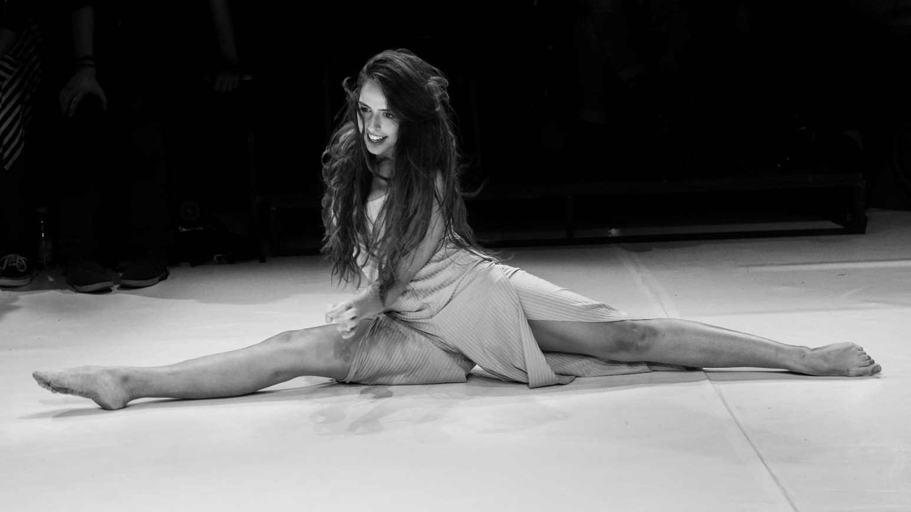

General informations

Birth year: 1995, height 1,75m.
Contact: 0723037771 , adadumitru1@yahoo.ro.

Foreign languages:
English and French advanced level.

Skills

- Dance ( did 7 years of professional modern dance going to competitions,two years of ballet and in the last years I practiced contemporary dance and movement theatre)
- motorbikes
- Vocal singing, accordion, piano, guitar
- fighting (box, martial arts, film fights)
- juggling
- theatre and film acrobacy
- stilts
- fencing
- horse riding

Studies

- She was selected to be part of Watermill summer camp in New York, coordinated by Bob Wilson.
- Acting masterclass with New York acting coach Susan Batson, Berlin 2019.
- At 13 she started 3 years acting programme, Popular School of Arts.
- At 15 years old she started School of Gestual Theatre coordinated by Mihai Malaimare in Mask Theatre, Bucharest. During the 2 year programme she stated working as a professional actor in the theatre.
- In 2014 she was accepted to LAMDA (London Academy of Music and Dramatic Arts).
- In the same year because of some personal problems she couldn’t leave the country for studies so she was accepted to UNATC (biggest university of theatre and film from Romania) having as main teacher the actor Florin Zamfirescu.
- Graduated BA at Theatre University of Bucharest (UNATC) in 2017.

Theatre experience

- Zita, "O noapte furtunoasa" written by Caragiale, directed by Laszlo Bocsardi, Alexandru Davila Theatre
- Izabella and other roles, "P experiment", directed by Alexander Hausvater, Alexandru Davila Theatre.
- Suzon, "8 women" directed by Erwin Simsenshon, Alexandru Davila Theatre.
- Whorehouse boss, ”The Minister's coffee", directed by Daniel Bucur, Art Theatre Deva.
- Collective part, "La ordin, Fuhrer", directed by Mihai Maniutiu, Jewish Theatre of Bucharest.
- Juliet,“Romeo and Juliet”, directed by Bogdan Cioaba, Alexandru Davila Theatre.
- "Fragile. Handle with care", contemporary dance show choreography by Mariana Gavriciuc.
- "Casting 1.8" directed by Alexandry Nagy, an underground theatre movement, 8PT.
- Rambuku, ”Rambuku” directed by Mihai Măniuțiu, coreography Andrea Gavriliu, stage design Adrian Damian, at National Theatre from Timisoara. This show was part of National Festival in 2017.
- Larisa Dimitrievna,”Fata fără zestre”, directed by Constantin Podu, Art Theatre Deva, 2017
- Varia, “The Idiot” by Dostoievski, directed by Bogdana Darie, Theatre Elisabeta, Bucharest.
- Collective part, ”Coriolanus” directed by Ducu Darie, Bulandra Theatre Bucharest.
- A fairy in „A middsummer’s night dream” directed by Petrica Ionesco at Bucharest National Theatre.
- 2011-2014 she was hired as an actress in Masca Theatre from Bucharest. At 16 she first performed on a professional stage with Milphiddippa in “Miles Gloriosus” directed by Mihai Malaimare. During the 3 years collaboration there she performed in many living statues shows, being also part of 3 editions of International Festival of Living Statues.

Film experience

- Gash, villain in "The Pact" TV serie, directed and produced by Bobby Barbacioru, Ahmed Albaker and Michael Philip. Starring Rick Ravanello, Louis Mandylor, James Marchall, Christian Brassington, Eyad Hourani, Natassia Malte, Louis Healy, year of release 2020.
- Ana, feature film "Tic Tac", directed by Bobby Barbacioru, produced by Luna Films.
- The women, leading, "Prison's talking room", short directed by Andy Lupu.
- Bluebell, serial killer, one of leadings in American TV Seriee „Three knee deep”, directed by Bobby Barbacioru, Luca Bergovici and Ahmed Albaker. Produced by Luna Films. Starring Louis Mandylor, James Marchall,Holt Boggs. Year of release 2019.
- The student, ”Coborâm la prima”, d. Tedy Necula.
- Cornelia, leading, ”Mi minor”, directed by Boby Barbacioru, Luna Films.
- Nurse, ”Escape vr”, directed by Millo Simulov. (first VR movie produced in Romania by Spider film)
- Lora, antagonist in Romanian TV series ”O grămadă de caramele”, Intact media, produced by Ruxandra Ion.
- Eva, leading, „A drop of blood„ directed Ovidiu Broştean.
- Ada, main in feature film “Marea cu sarea” directed by Mihai Panaitescu, movie part of VSLO film festival and „Dublin International Film and Music Festival” .
- Leading in 4 episodes of Romanian Tv serie „Lessons of life” produced by ProTV, directed by Sebastian Voinea, Titus Scurt și Silvian Voinea.
- music video „Truth or lie„ (Nicoleta Nucă şi Cabron) directed by Bogdan Daragiu.
- Commercial AUDIBLES, d. Spencer Susser.
- Commercial Selgros, d. Mircea Rosu.
- Commercial, d. Ben Lacour.
- Commercial Swiss travel
- Music video for Romanian band ROA.
- In University she collaborated with directors from Film school (Cristina Popa, Lorand Gabor, Dumitrana Teodora Lupu, Ovidiu Brostean) with whom she did several short movies.
- She collaborated with the American famous entertainer Nas Daily for two epsiodes.

Awards and festivals

- ”Best actress in a leading” with “The Iditor”, Okaua Festival, București 2016.
- "Rambuku" won UNITER award "Best show of 2018"
- Sarajevo International Theatre Festival and International Meetings of Cluj, both with "Rambuku"
- Big award of ”International Theatre Festival Actor of Europe 2017” Macedonia, Skopje with ”The Idiot” by Dostoievski.
- National Theatre Festival 2016 in off with “A clown’s world” directed and performed by her.
- National Theatre Festival 2017 official selection with “Rambuku” by Mihai Maniutiu.
- ”Best actress in a leading”, Festival des Écoles du Théâtre Public, Franța 2013.

Workshops

- Workshop by Thomas Richard and Mario Biagini (Grotowski's workcenter)
- Workshop „Introduction in Etienne Decroux’s technique, coordonated by Steven Wasson and Corine Soum (Theatre L'ange Fou, last assistant of Etienne Decroux)
- Workshop on comedia dell'arte, coordonated by Michele Modesto Casarin from Venice, Italy.

Modeling career

- She had a collaboration with Fashion Tv for one year, 2011.
- She started foto modeling being part of several photo projects done by important photographers from Romania. Worldwide known project “Urban love” by Natalia Mândru, “Special moments” by Sorina and Mircea Dascălu “Ballet” by Andreea Zamfirescu. Also worked with Vlad Eftenie, Volkmer, Ovidiu Pistritu, Grigore Roibu etc.
- Model for several photo workshops by f64 teacher Radu Tudoroiu.
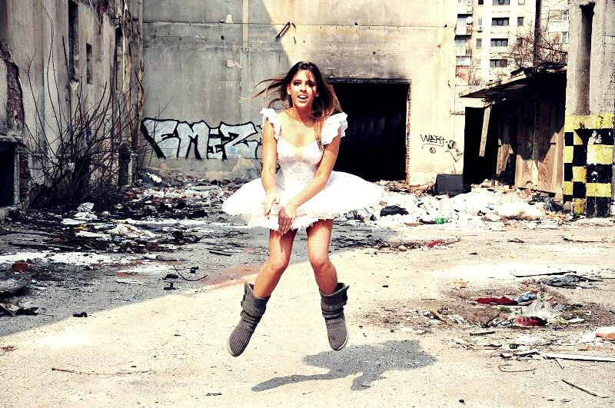
İmdb : https://www.imdb.com/name/nm9360714/?ref_=nv_sr_1?ref_=nv_sr_1

